Gift Aid is reclaimed by the gap* from the tax that I pay for the current tax year. If I pay less Income Tax and or Capital Gains Tax in the current tax year than the amount of Gift Aid claimed on all my donations, it is my responsibility to pay any difference. I have given my home address to identify me as a UK taxpayer. The gap* reclaim 25p in tax back for every £1 that I donate.

❑ I want the gap to treat all gifts of money that I have made in the past 4 years and all future gifts of money that I make from the date of this declaration as Gift Aid donations.

Date......./....../......./ Signature.......................................................................................

* You can cancel this declaration at any time by contacting us at [gap.huboffice@gmail.com](mailto:gap.huboffice@gmail.com).

* If you pay tax at the higher rate you can claim further tax relief in your Self Assessment tax return.

* Please notify us of any changes in your name and/or address.

Please return to: The Treasurer,

The gap*, Our Place Support Hub, Farthing Lane, Sutton Coldfield B72 1RN

**THANK YOU SO MUCH FOR SUPPORTING US AS WE INVEST IN THE LIVES OF YOUNG PEOPLE**

**Amount £**........................ **One-off gift**  **Monthly** 

**Donor details** (Please use Block capitals) **Title**...........**Forename**.............................................**Surname**............................................................ **Address**............................................................................................................................................. ...........................................................................................................................................................

**Postcode**............................

If you are choosing to support the gap* regularly/monthly, please set up a Standing Order with your own bank

The gap* Bank Account: The gap, Nat West Bank – Sort Code 60-21-07 – Account No: 50159658

**Would you support us?**

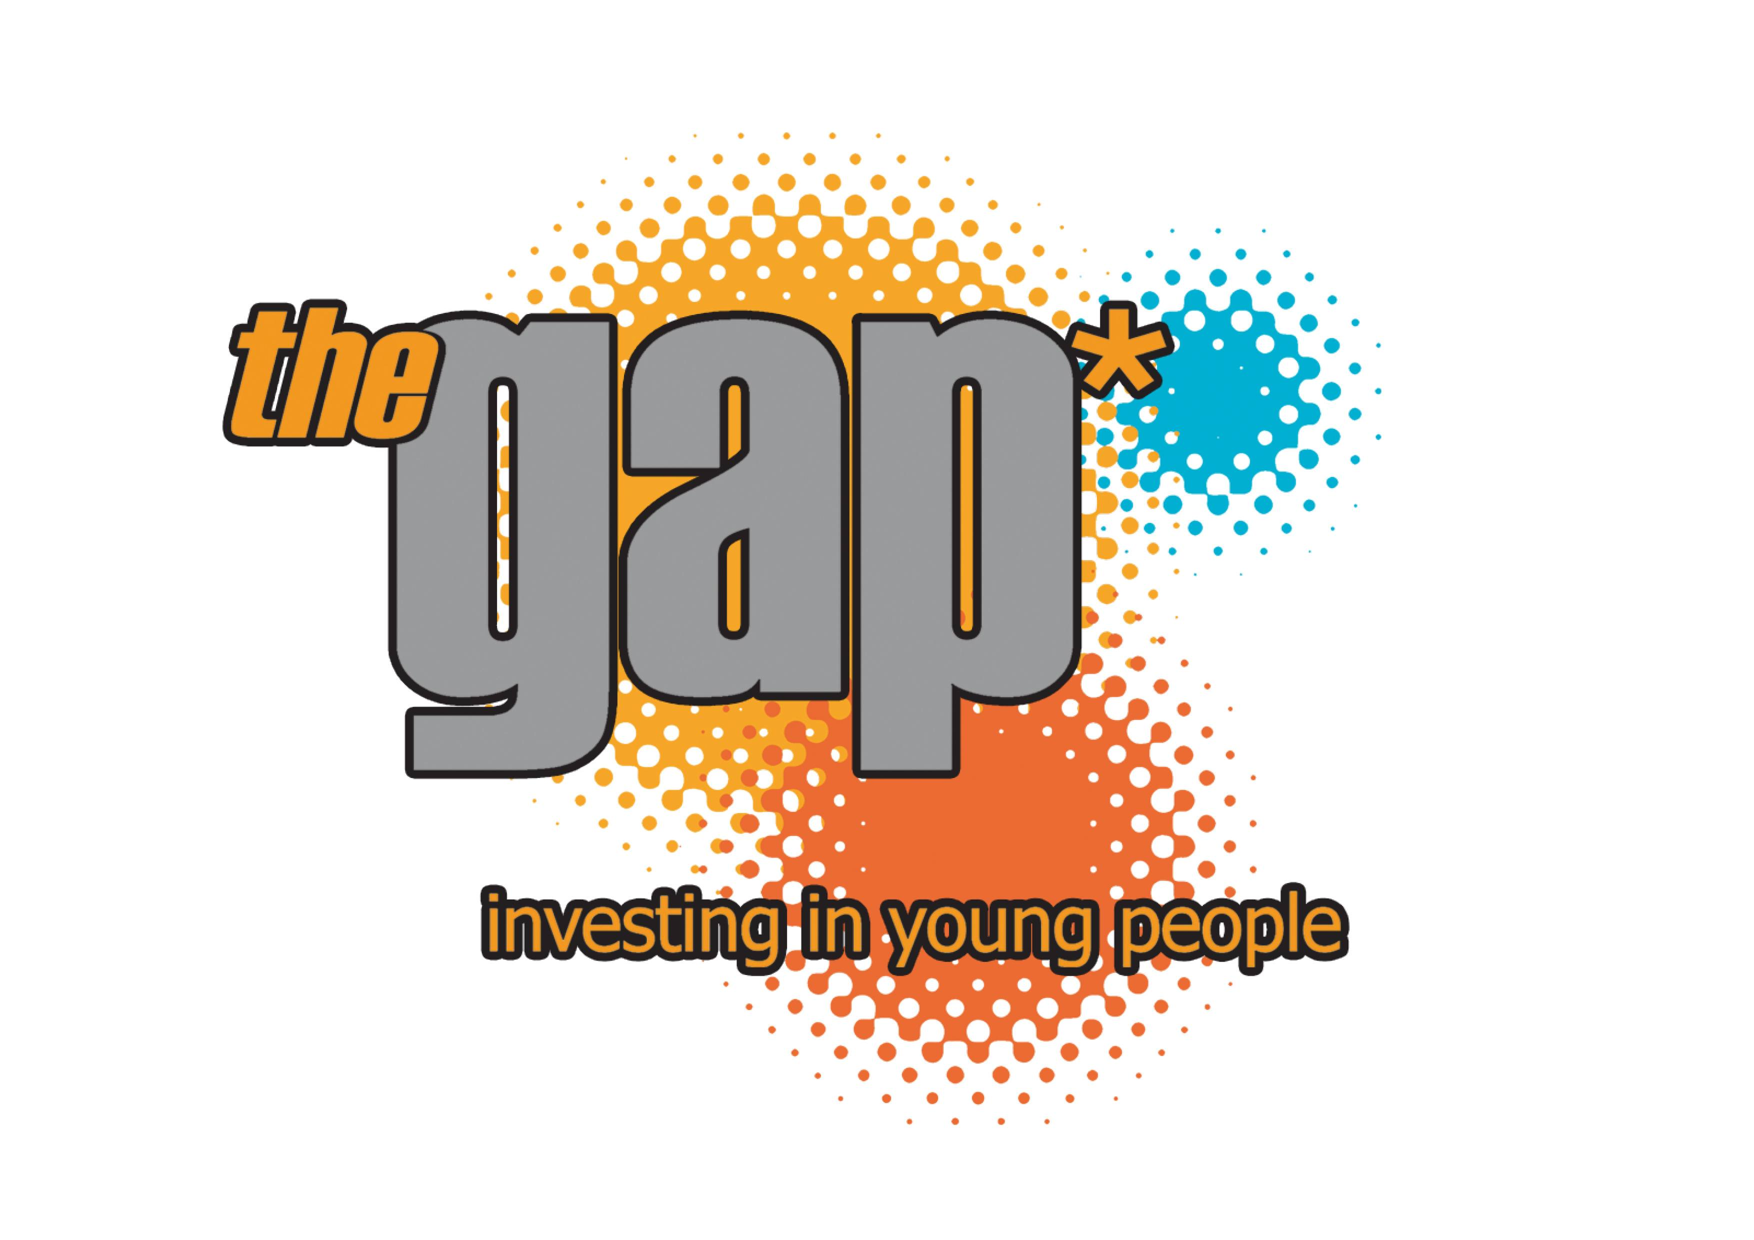

Investing in young people

